AWS EMR with Hive

### Create an Amazon S3 Bucket:

* Create bucket:

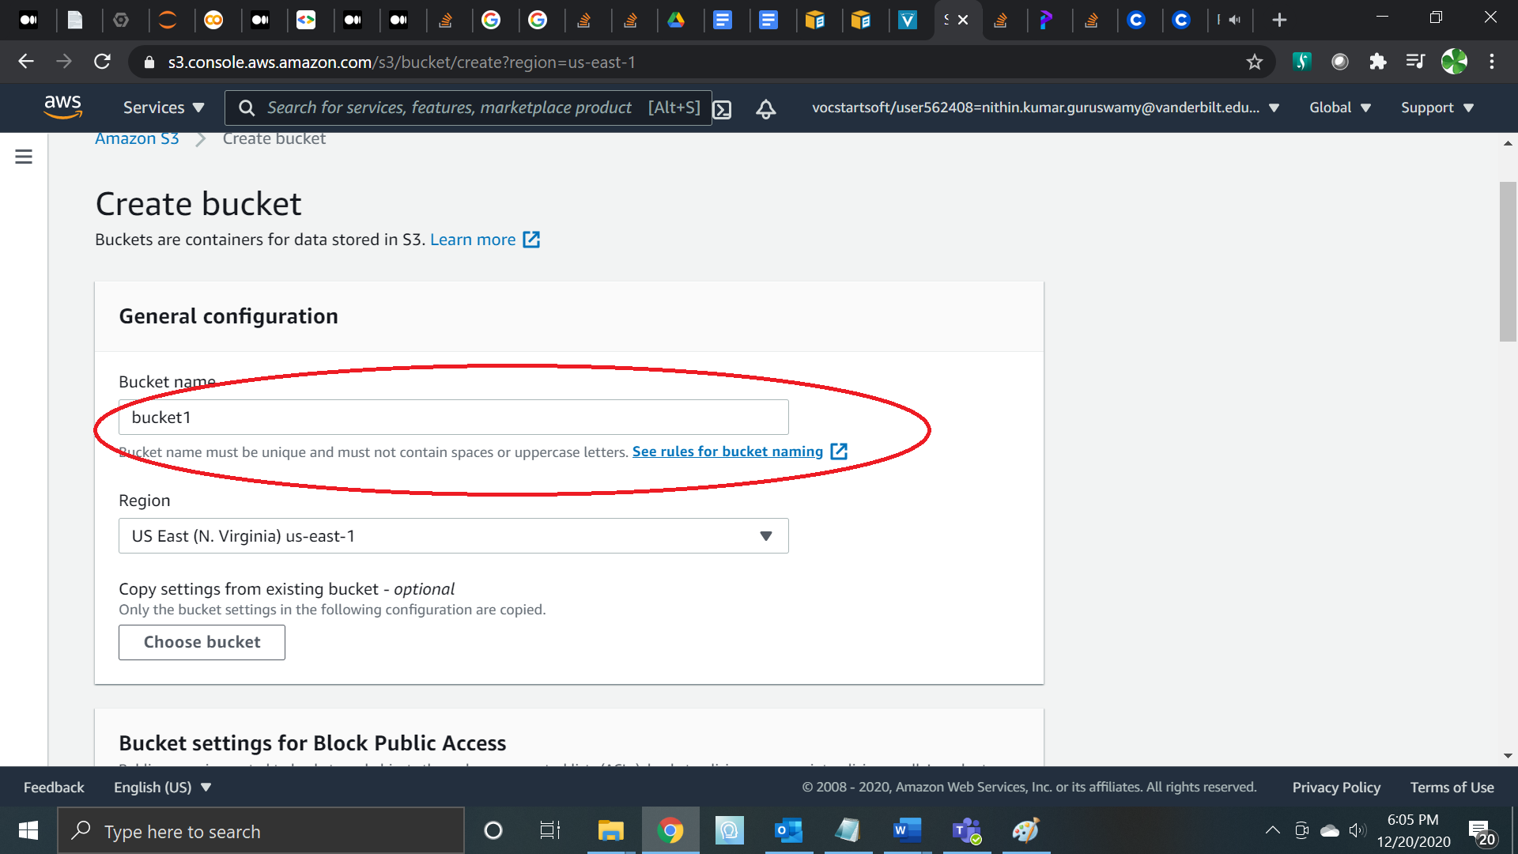

* Create the bucket

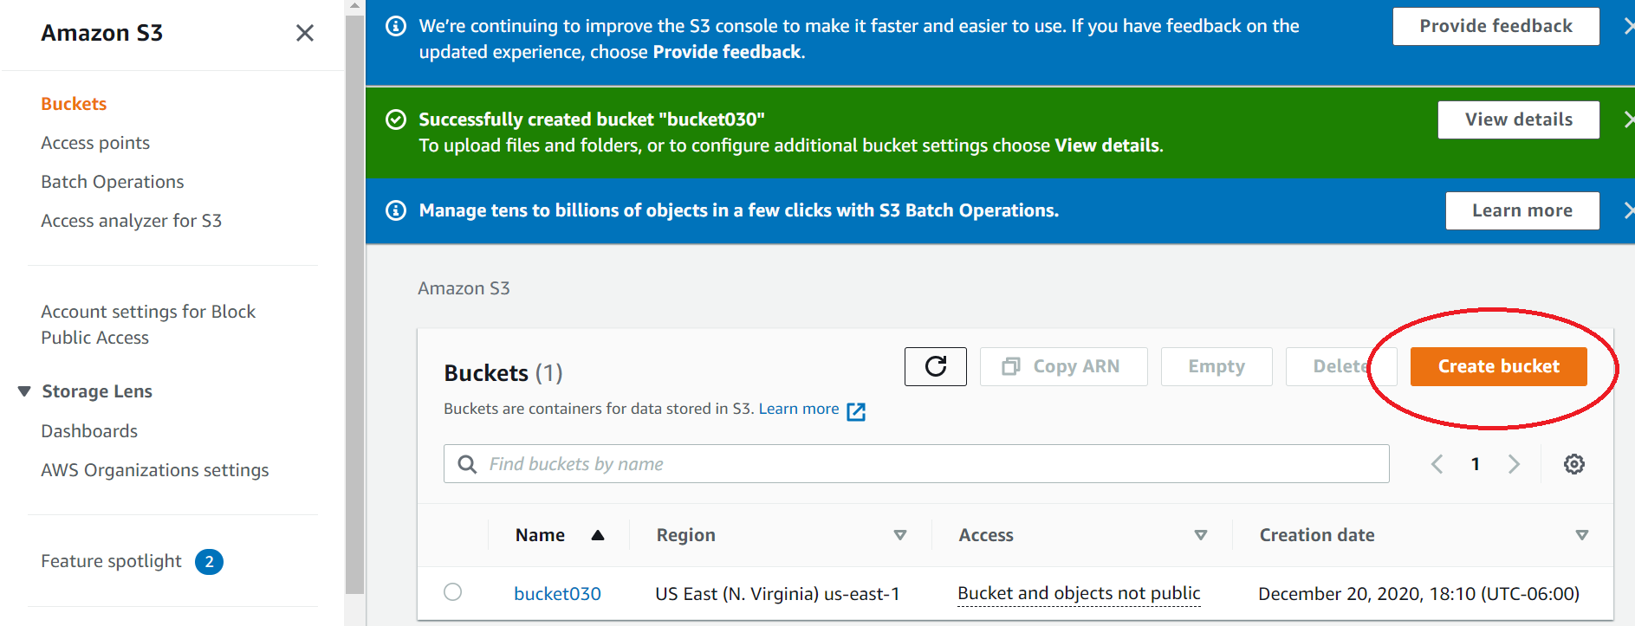

* Upload the files on the bucket

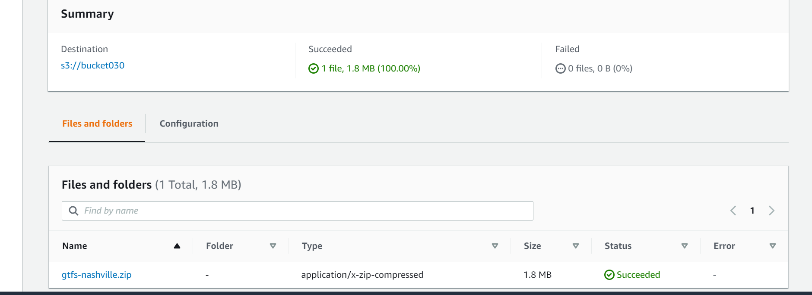

* Download the files from the bucket

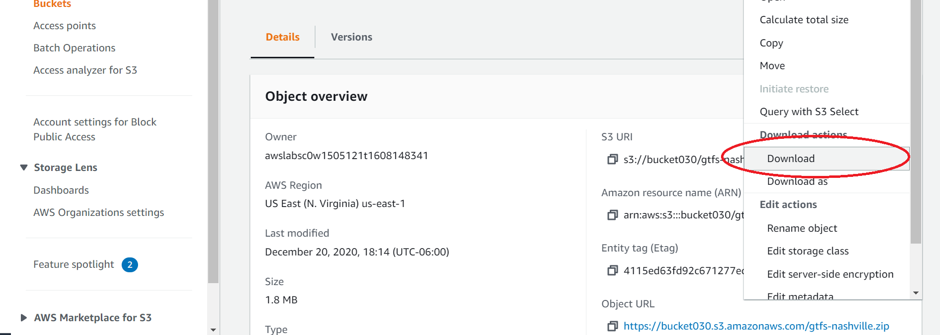

* Create cluster:

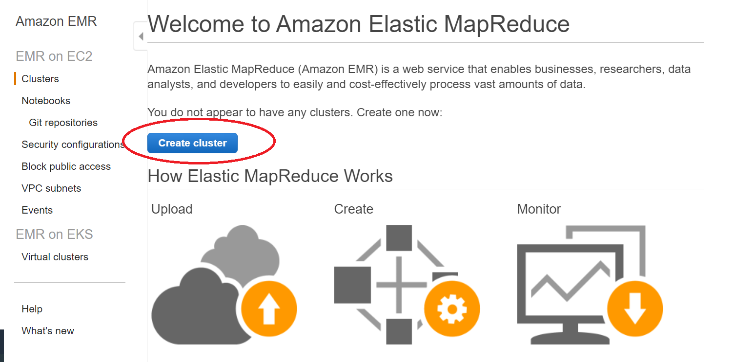

* Name the cluster

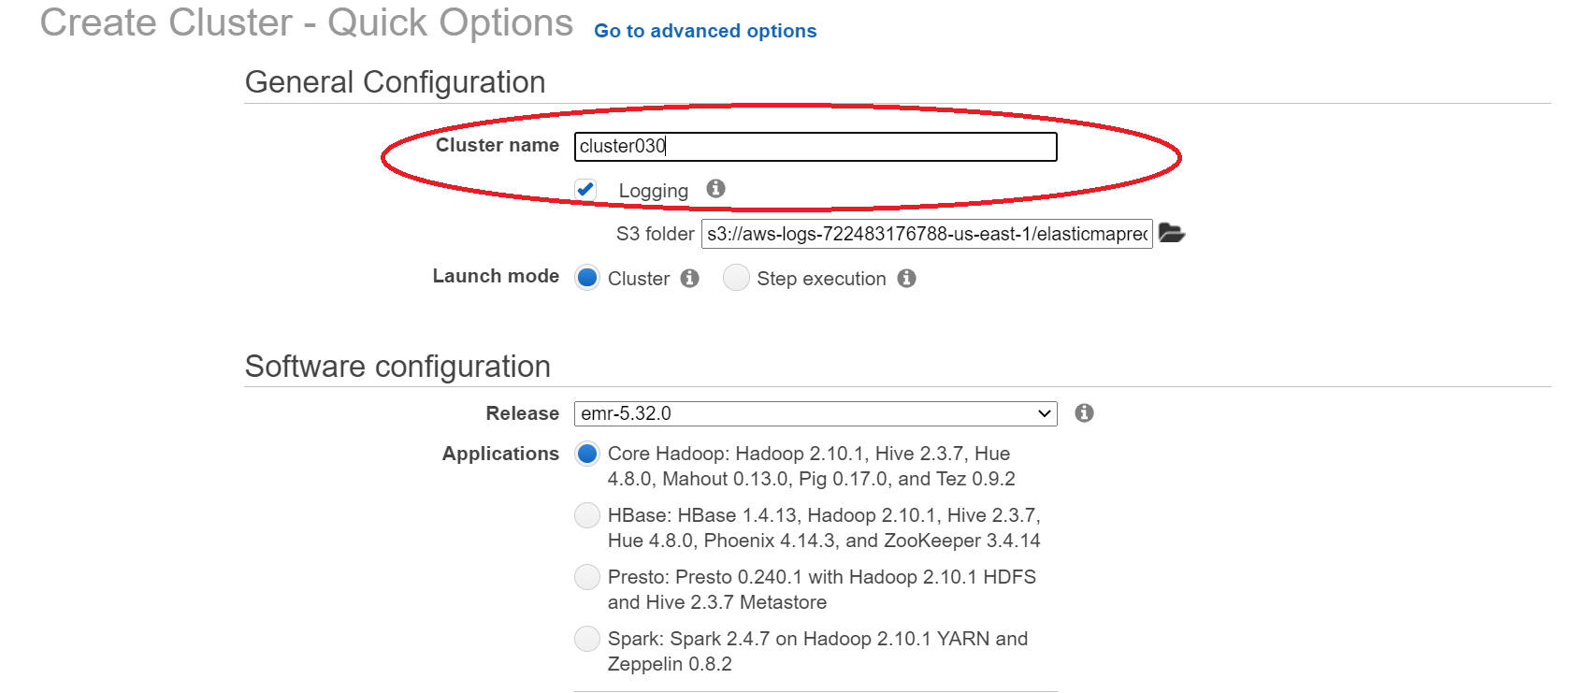

* Select a key pair or create a new one and click create cluster:

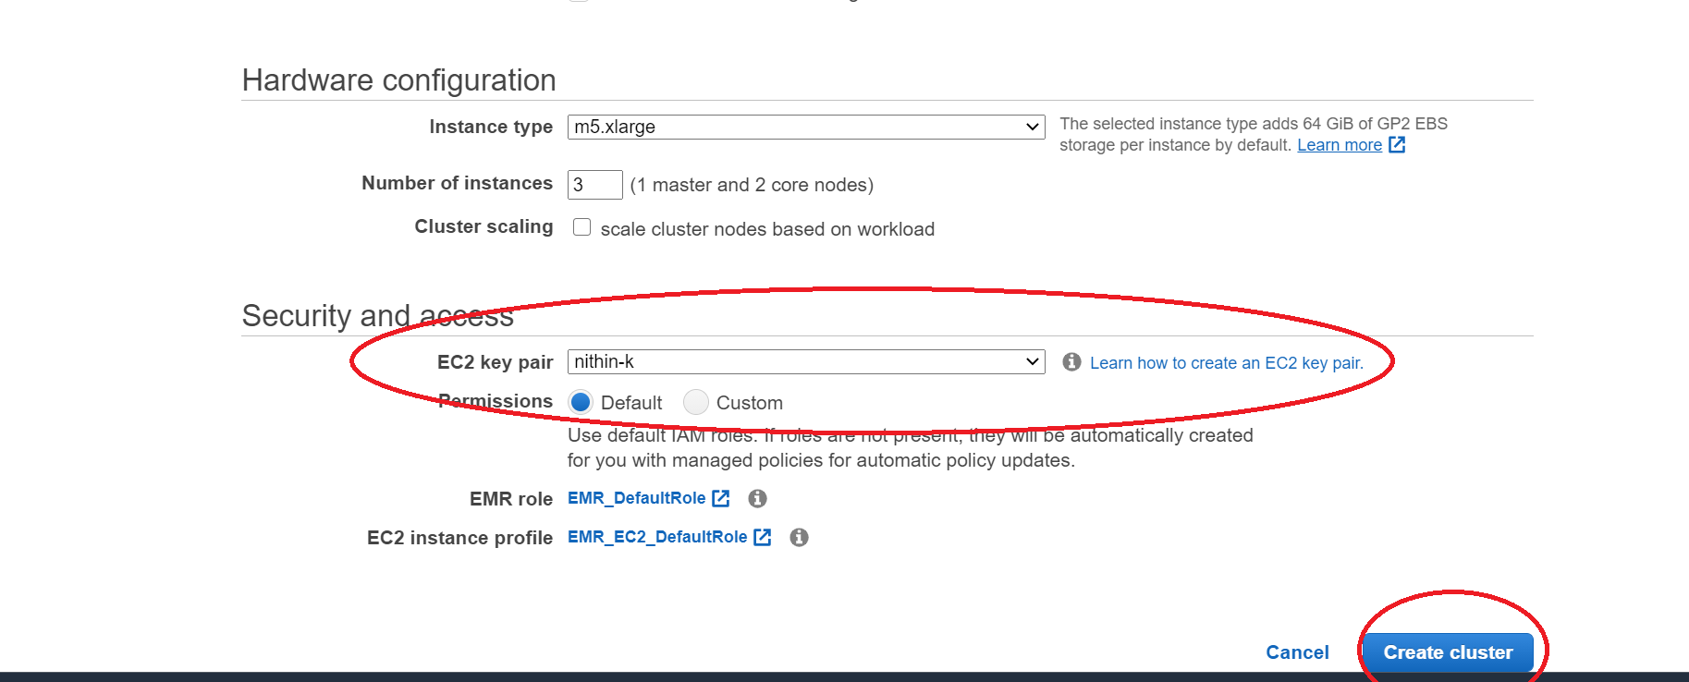

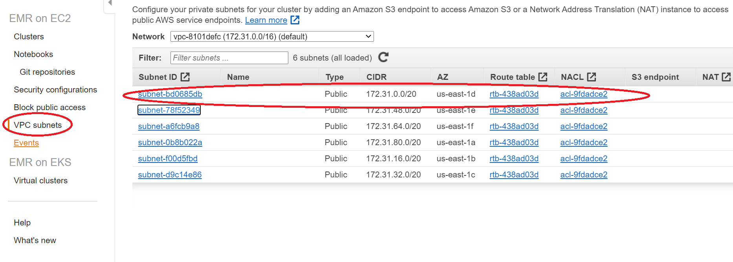

* Edit the security group of Hadoop master and hadoop slave to connect ssh

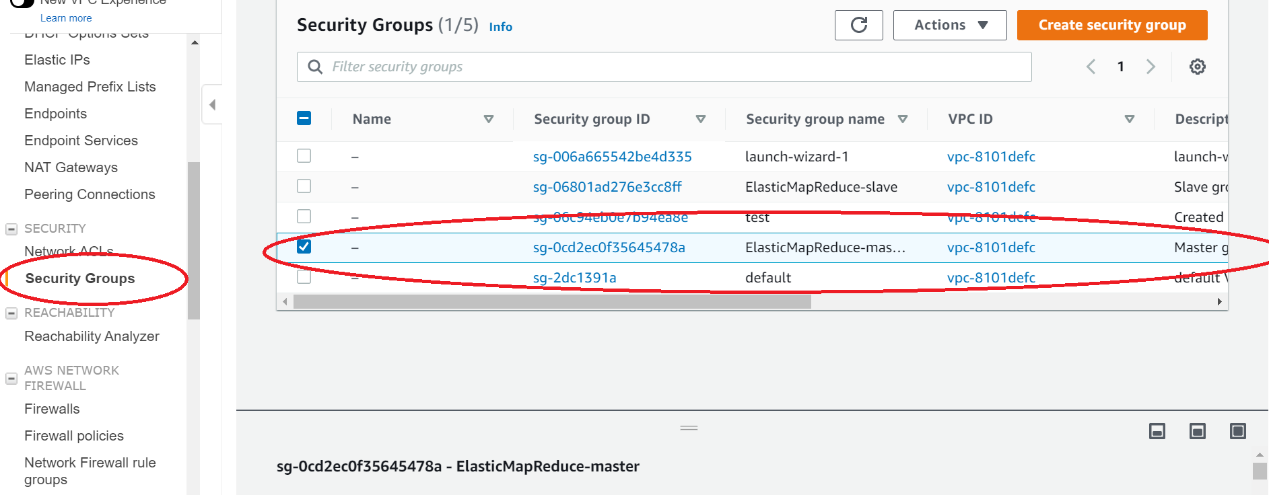

* Edit the inbound rules VPC

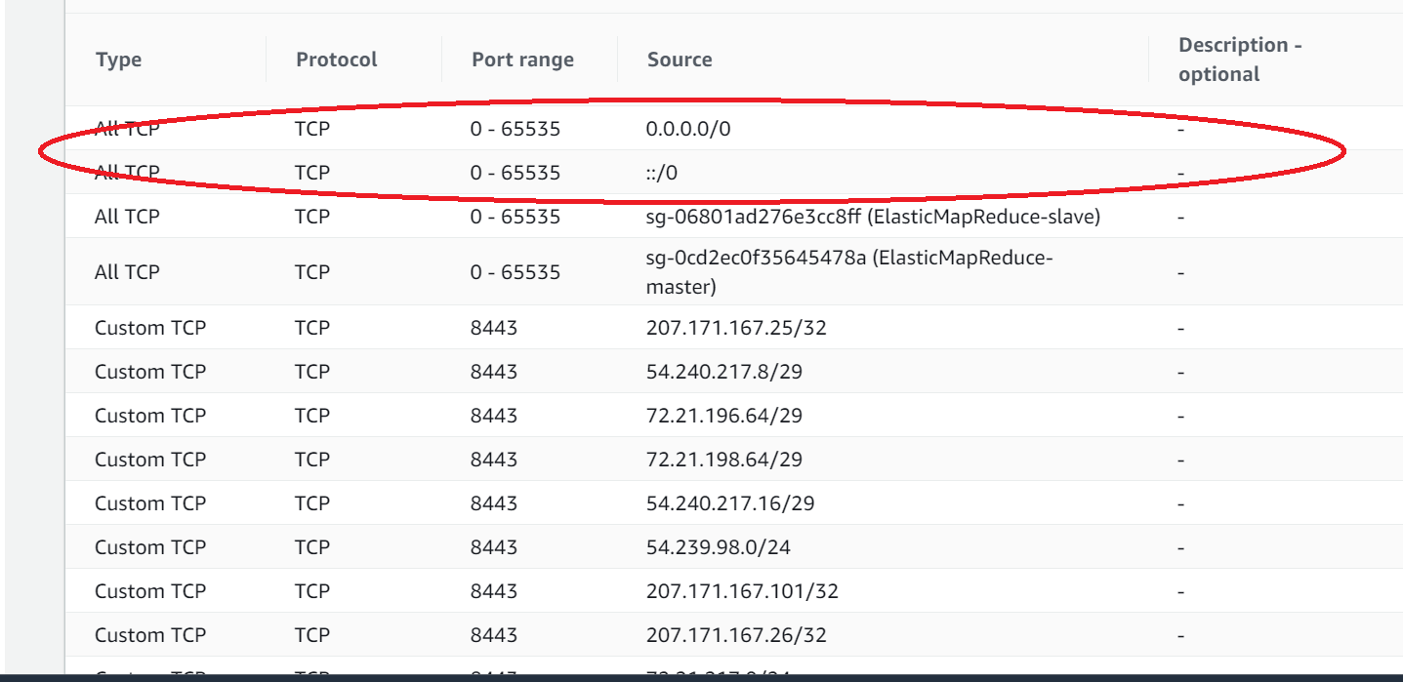

* Connect to the Master

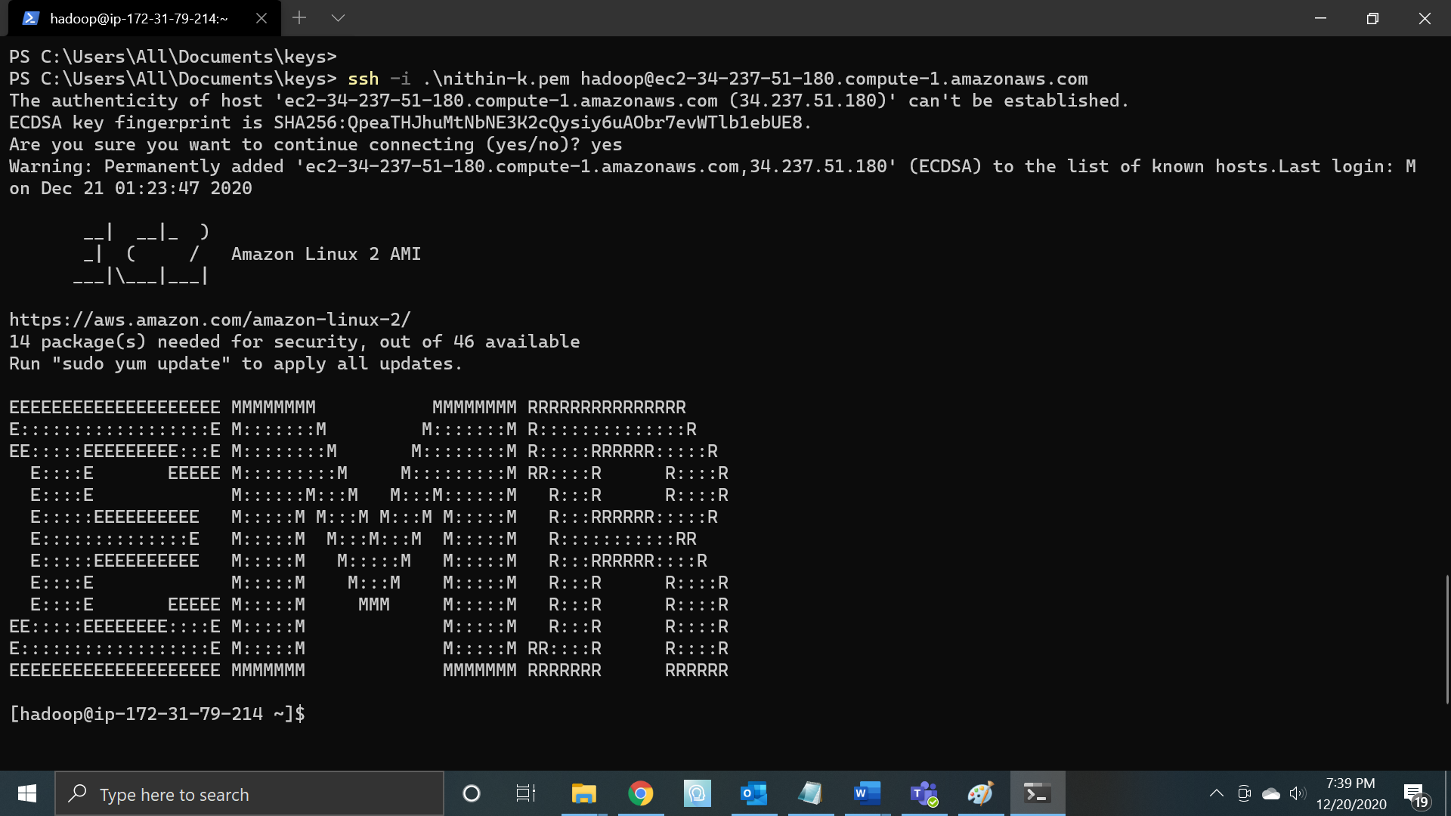

* Run a sample MR job using Hive script:

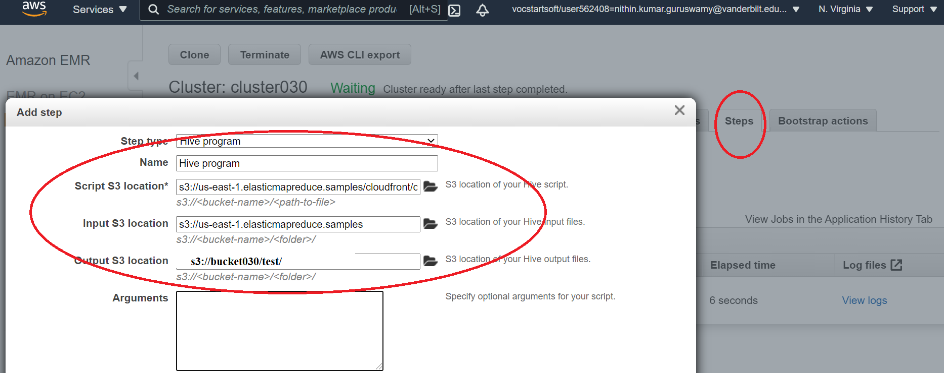

* Hive job completed

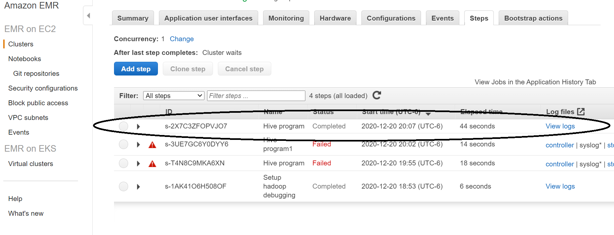

* Result available in S3 bucket

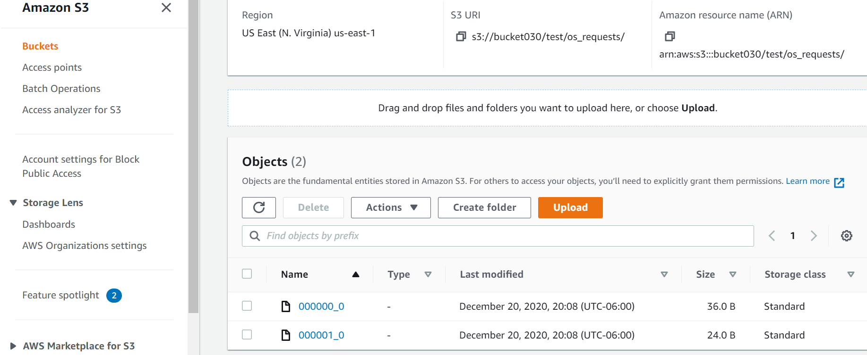

* Terminate the cluster after job is done to save the AWS credits from getting wasted.
* Also delete all the buckets.

